|  | 2814ICT/7003ICT – Data Management / Database Design  School of Information & Communication Technology |
| --- | --- |

**Lab 4.3 Exercise**

**1. Write the MySQL statements.**

For the given MovieCo ERD below, write MySQL statements:

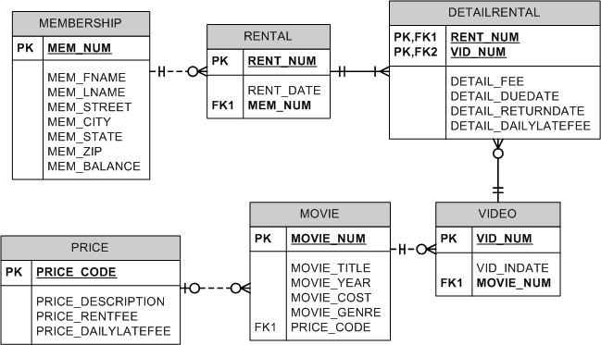

a) Find number of movies that cost at least $50.

***Hints:***

* Use the COUNT(*) function in SELECT statement to count the number of movies.
* Use the WHERE clause to compare movie price.

**Your answer:**

Select Count(MOVIE_NUM) from MOVIE where MOVIE_COST >=’50’;

b) Find number of members from each state. Show state and the number of members.

***Hints:***

* Use the COUNT(*) function in SELECT statement.
* Use the GROUP BY clause to group members under each state.

**Your answer:**

Select MEM_STATE,Count(MEM_NUM) from MEMBERSHIP GROUP BY MEM_STATE;

c) Find the members who rented at least one movie. Show membership number, his/her full name.

***Hints:***

* Use the CONCAT function in SELECT statement to merge member’s first and last names.
* Join two tables (Rental and Membership) and use WHERE clause to remove irrelevant rows.
* Use the GROUP BY clause to group all rentals under each member.
* Use the COUNT(*) function in HAVING clause to count the number of movies rented by each group (member).

**Your answer:**

Select RENTAL.MEM_NUM, CONCAT(MEMBERSHIP.MEM_FNAME,MEMBERSHIP.MEM_LNAME) AS Full_name FROM MEMBERSHIP ,RENTAL WHERE MEMBERSHIP.MEM_NUM = RENTAL.MEM_NUM GROUP BY RENTAL.MEM_NUM HAVING COUNT(RENTAL.MEM_NUM)>=1;